EFI Staff Discussion Note Proposing a Mechanism for Implementing the Evolution Roadmap on Climate
Dirk Heine
October 2024

Abstract
The simultaneous climate and fiscal crises of this decade necessitate a transformative shift in the World Bank Group's (WBG) strategy. The urgency for climate action, highlighted by the Intergovernmental Panel on Climate Change (IPCC), is compounded by the deteriorating financial capacity of governments in emerging markets, which face record emissions and debt levels. Today's climate finance system reflects past needs, but policy reforms are essential for keeping the climate transition costs within countries' fiscal space. Additionally, mobilizing private-sector investment requires a shift from project-based climate finance to policy-focused support. However, the current climate finance architecture not only fails to support policy reforms but actively discourages them.
To address this challenge, the proposed Evolution Roadmap seeks to enhance the Economic and Financial Institutions' (EFI) capacity for climate policy lending, aiming to increase the climate components of Development Policy Financing (DPFs) from 25% to 40%. This initiative proposes a funding model that rewards countries undertaking significant climate reforms as global public goods. Two financing options are outlined: topping up dedicated DPFs with bilateral climate finance and establishing a global mechanism to augment any DPF featuring agreed-upon transformational policy actions. Both models aim to integrate climate policy into macro-financial frameworks, reinforcing the WBG's role as a facilitator of global solutions while aligning climate finance with broader developmental goals. The paper also includes a Draft List of Transformational Climate Policy Reforms backed by EFI GP Programs.

The Problem
The coincidence of climate and fiscal crises this decade requires a shift in WBG strategy. The IPCC reminds us that this decade will be decisive for climate action. But, while time to avoid tipping points toward global decay is running out, the ability of governments to finance that climate action has worsened dramatically. Emerging markets are at record levels not just for emissions but also for total debt. Nevertheless, proposals on climate action – including the World Bank’s CCDRs – remain insensitive to these macroeconomic constraints and call for multi-trillion USD in additional spending per year. In this mess, new solutions are needed to avoid a clash of climate and fiscal priorities. The longer the delay in such reforms persists, the more expensive the transition becomes and the greater risks it poses for global macro-financial stability. Already now, the Bank of International Settlements warns about a near-term climate-induced financial crisis of unprecedented scale.
Policy reforms are indispensable for keeping the cost of the climate transition within countries’ fiscal space. The low-carbon transition is held back by widespread energy subsidies, regulations foreclosing market access for green technologies, higher tariff rates for green goods, outdated designs of financial regulations, and other government failures. Forcing the low-carbon transition through public investment projects without addressing these policy distortions unnecessarily escalates cost and undermines incentives for mobilizing private finance.
Decarbonization requires stepping up investments.  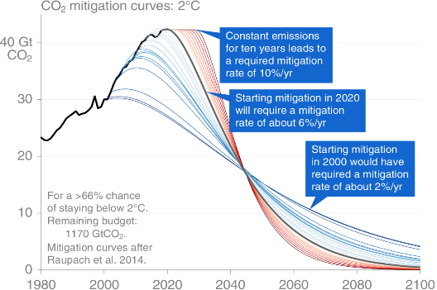  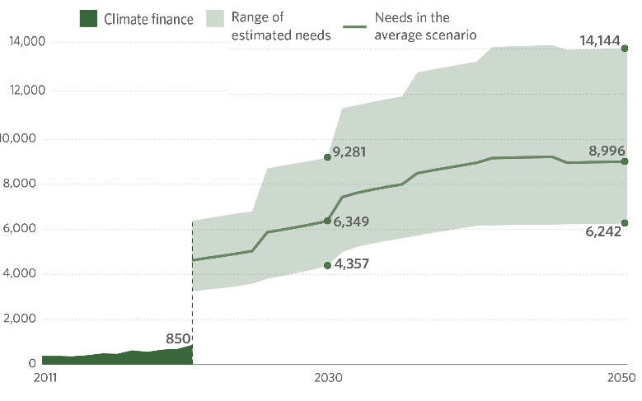  Needed pace of mitigation for achieving Paris Agreement as a function of when mitigation starts  Million USD | These investment needs rise the longer countries wait, because, for meeting any decarbonization target, delay escalates the needed pace of future macrostructural change.  \\\
The largest changes are needed in WBG client countries as they now account for two thirds of global emissions and are most affected by the consequences.  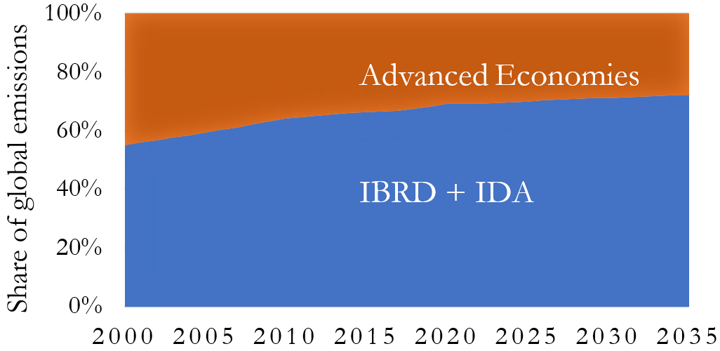 | But their fiscal space to finance decarbonization is dwindling.  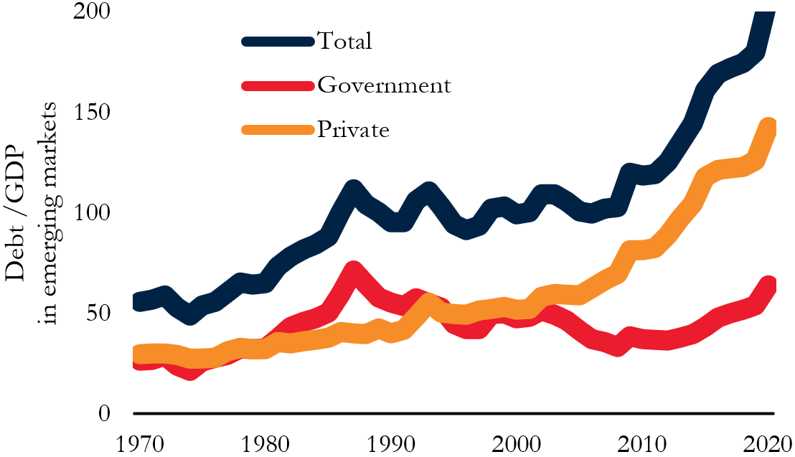
Aligning climate and fiscal targets thus requires increasing the private-sector share in available climate finance.  But the opposite is happening.  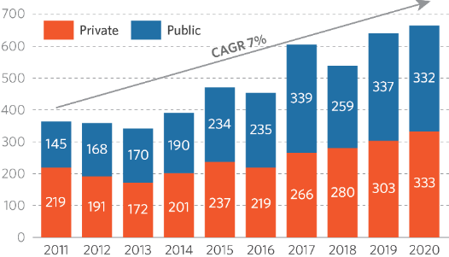 | The lackluster private-sector share contrasts with improving profit opportunities from scale economies in Greentech cost.  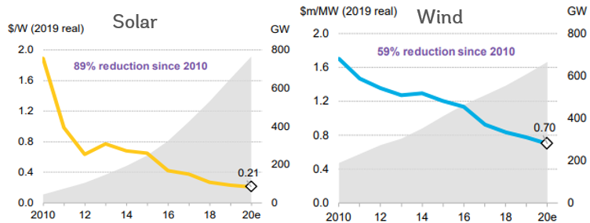
Instead of technology cost, the decisive barrier to growing private-sector low-carbon investments is now fiscal policy!  Explicit fuel subsidies are at record levels…    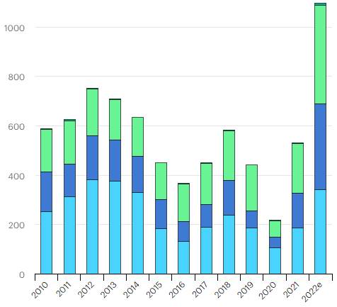  Billion constant USD in direct subsidies to | … with 6tn USD in annual implicit fuel subsidies, …  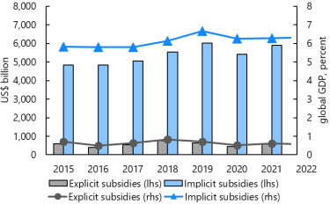
… and 500bn per annum in tariff rate advantages for high-carbon goods relative to lower-carbon ones. 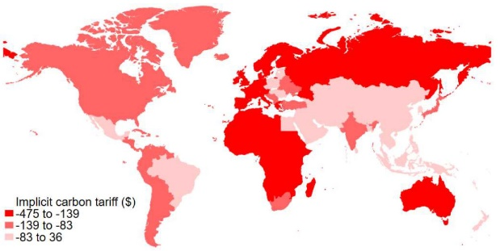 | Where governments act on climate policy, such action is often very volatile, which fails to provide the needed stable phase-in of market signals that de-risks green private investments.  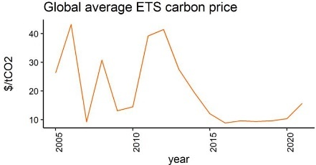  These unstable market signals are driven by actions of line ministries without coordination of macro-level interaction effects by Finance Ministries.
All these policy barriers undermine the Private Capital Enabling Environment for green investments.  Policy barriers inflate the overall investment needs for reaching climate targets and its needed public-sector share.  Like trying to score a goal on a tilted playing field: it takes a much bigger push than would be necessary in normal market conditions.  Stepping up policy reforms would bring down the needed investment push, aligning with available fiscal space. | 

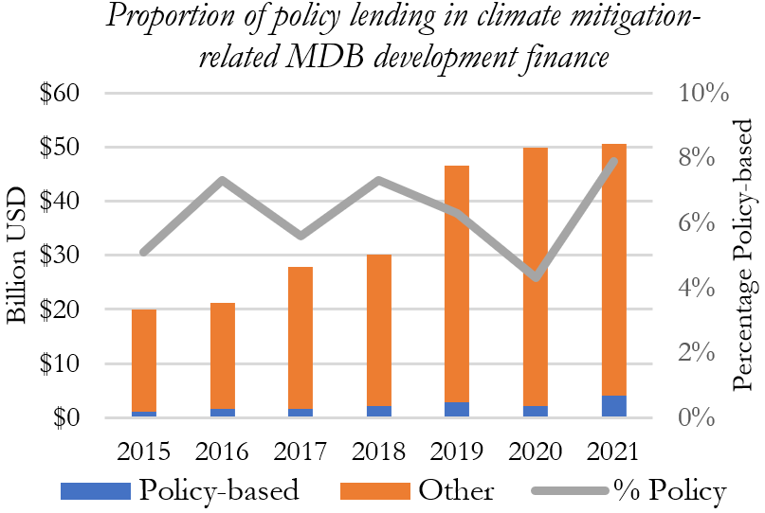
Nevertheless, only a minor share of global climate finance supports policy reforms. Only 5-7% of climate financing provided by MDBs since the Paris Agreement has been for policy reforms. The share is even lower (about half) when adding bilateral climate finance and global trust funds (CIF, SCF, GCF).
Today’s climate finance system reflects previous needs. Under the 1998 Kyoto Protocol, developing countries did not face obligations for policy reform, but were encouraged to engage in mitigation through externally financed investments, essentially to grow demonstration projects. The climate finance system was designed for that piloting purpose. However, in the 2015 Paris Agreement, developing countries agreed to design policy plans for mitigation (NDCs), and implement mitigation at an economy-wide scale, which requires transitioning from project-level action to policies that provide incentives mobilizing the private sector. In the 2021 Glasgow Climate Pact, countries went further to agree on the adoption of a first specific universal climate policy reform applicable globally: phasing out fuel subsidies (aka negative carbon prices). Current global climate initiatives take these policy commitments further. The largest joint statement by economists in the history of the profession emphasizes fiscal policy, not projects. 84 Finance Ministers have committed to a set of globally applicable policies and practices (Coalition Principles). Leading academics and the G7 are proposing a Climate Club based on policies. The IMF, OECD and WTO are putting forward proposals for positive carbon price floors. The EU is starting to condition market access on overseas carbon pricing and land-use policies. Taken together, the international community has thus significantly stepped-up demands on developing countries for climate policies (rather than just “climate action” in general) but has not yet backed up these demands with an increase in policy financing.
Private-sector mobilization, too, requires a shift of climate finance from projects to policies. To achieve climate mitigation at scale, financing must come from the private sector. In the past, a primary inhibitor of those private investments was the high cost of low-carbon technologies. To address that barrier, it was appropriate to focus available public climate finance on investment lending where it could be geared at demonstration projects. But with cumulative increasing returns to scale, the low-carbon investments are, in many countries, becoming the least-cost option. Technology costs are ever less the binding constraint. Today, low-carbon profit opportunities abound. What is now holding back the Private Capital Enabling Environment is policy barriers, including the risk from uncertain policies. Accordingly, the shares of investment project lending and policy lending in climate finance need to be revisited.
Today’s macro-fiscal situation requires the same direction of strategy change. The rising interest rates and dwindling fiscal space make it increasingly unrealistic to close the climate finance gap via public investments. To instead mobilize private finance, governments need to provide incentives, and policy reforms are the cheapest scalable way for delivering those. Also, for decades, traditional project-based approaches to Private Capital Mobilization have yielded mediocre results, leading to calls for focusing on Private Capital Enabling Environments instead. With tightening public finance, that shift in focus takes on added urgency, and calls for orienting climate finance from projects towards policy reforms.
Yet, the current architecture of climate finance not just fails to support policy reforms – it discourages policy reforms. There is a long-nurtured expectation that the core of the future climate finance system will be “carbon markets”. A common vision for such carbon markets is that developing countries would sell emissions-reductions from offset projects (micro level) or the over-fulfillment of their NDCs (macro level) to emitters in advanced economies. In reality, carbon offset markets have remained tiny and face major barriers to growth. Nevertheless, for 20 years, expectations have been nurtured that a breakthrough is imminent. In the current narrative, that breakthrough will happen in 2030 through firms voluntarily paying for their emissions or advanced economies agreeing to do so via Paris Agreement Article 6. The World Bank (SD) has been at the core of agencies creating these expectations, and prioritized programs for getting “carbon market-ready” over any climate policy programs. Now client countries have come to expect that they will be able to profit from carbon markets if their future cost for reducing carbon is below their expected global carbon market price. Many policymakers additionally understand that the marginal cost of reducing carbon rises with the amount of mitigation undertaken. Putting these elements together, they understand that a country which implements climate policies today reduces the volume of mitigation projects that can be done in the future (base effect) and reduces the profit margin from selling these projects (cost effect). Accordingly, a country that implements climate policy today must expect to benefit less from carbon markets and project finance tomorrow! This means that the climate finance system not only fails to substantially support reforms through policy-based climate finance, but even creates financial disincentives to policy action. And these expectation effects not only undermine the incentives for doing policy reforms today, but do so especially for those types of policy reforms that best align with macrofiscal policy.
These perverse incentives also hold for proposed carbon markets between sovereigns. With these, expectations have been nurtured that developing countries will be able to receive climate finance if they over-fulfill their climate commitments – the Nationally Determined Contributions (NDCs). However, creating such systems implies that setting more ambitious mitigation targets makes accessing climate finance harder. And countries understand that: Vietnam, for example, indicated to the WBG President that they regret setting an ambitious NDC as they expect it will lead to receiving less climate finance.
Current WBG reforms may further aggravate these problems. Even while both the SD VP and SD Senior Climate Advisor indicate that “carbon markets are not working”, SD is further stepping up external communications creating expectations around carbon markets in client countries – for both firms and sovereigns. Furthermore, from FY24, the WBG will condition its lending on compliance with client countries’ NDCs. This means that countries which set themselves a more stringent NDC face higher barriers for accessing WBG development finance. If a country instead sets a laxer NDC, the risk of any proposed WBG lending operation being incompliant with that NDC is lower. The WBG “Paris Alignment” methodology thus provides easier access to development finance when countries adopt weaker NDCs – trading off development and climate action, and undermining incentives for aligning NDCs with the Paris Agreement. There is an easy fix to this problem which EFI has repeatedly proposed to OPCS and SD, but for now, the disincentives stand.
These perverse incentives could all be solved through a counterbalancing of project finance with policy financing. But with the current extreme setup of the global climate finance system, which is close to a corner solution with almost no policy financing, any additional perverse incentives against policy change are especially harmful. This also implies that climate action does not necessarily benefit from additional climate finance if the shares are wrong. Likewise, climate action could improve if the shares were changed even if overall available funding does not rise.
But current initiatives to raise climate finance on policy reforms do not address the root problems. SD is proposing a new trust fund, SCALE, to provide results-based finance for climate action, including with a pillar focused on financial and fiscal policies. Aiming for 5bn (with no funds raised so far), spread over several years, the initiative does not materially change the policy proportion of the annual 87bn in DFI climate finance. More importantly, the funds are intended to be paid to countries four years after a successful policy reform (after a sustained reform achieved emissions reductions), whereas the main political barriers to climate policy materialize at the time of introducing the reform. For example: a country phasing out fuel subsidies needs most support during the reform itself, not years after it succeeded. Also, results-based climate finance can reward a successor government for the reform of their predecessor, sometimes rewarding exactly those who pushed against a policy. Results-based climate finance and the current design of SCALE are therefore not a solution to the lack of climate finance enabling policy reforms. This does not mean that SCALE could not have a role: it can help provide incentives against policy reversal, but it does not enable the reforms getting started in the first place – which is the main problem for exactly those types of climate policy reforms that best align with long-term development.
A reform is needed also to future-proof EFI, and the World Bank, in a fast-changing global institutional landscape. Without policy change, the push for climate investment clashes with core EFI objectives of macro-financial stability. This clash puts EFI into a dangerous position if its necessary role as a guardian of public finances becomes seen as a drag on global climate action. EFI needs to come out of the defense game on climate and propose its own vision that combines macro-financial and planetary stability. Including to stand its ground in competition. The vacuum of policy reforms in climate finance currently yields calls for action from multiple other international institutions. The World Bank is strangely absent. Last year, the G7 explicitly dropped the WBG from consultations on a global carbon price floor, following presentations from SD. Until recently, the World Bank was hardly agile in the core global fora for engaging central banks and finance ministries on climate change (NGFS, Coalition). Its CCDR process continues the investment project focus, with its few policy reform elements disconnected from investment gap analyses. Mushrooming climate initiatives from competing macro institutions like the IMF, OECD, BIS, FSB, IFRS and WEF risk sidelining EFI. There is an urgent need for a product to assert EFI’s role in reorienting the WBG’s climate work to align with EFI priorities, and self-determinedly show the path forward on macro-smart climate action rather than playing a defense game. It is time to communicate EFI’s own vision of the future of macroeconomics in this carbon-constrained world economy.

A Potential Solution Through the Evolution Roadmap
128+ ASAs are now building EFI’s capacity to raise the scale and development-alignment of climate policy lending. EFI has already declared its ambition to raise the climate components of its DPFs from 25% to 40%, and to ensure that these climate components better align with macro development objectives. To achieve this, a $78m EFI capacity building effort is underway: training staff and clients, making core diagnostics climate-smart. This effort, together with the EFI co-led Global Shield Against Climate Risks, is fast developing the needed analytical foundations and country dialogues to systematically integrate climate into EFI-style policy reforms.
But expanding climate policy reforms not only requires additional technical support to countries. The incentive problems need to be addressed, too. Countries undertaking transformational climate reforms contribute to a Global Public Good, which justifies providing them with additional funding beyond IBRD/IDA country envelopes. In the past, when countries substantially contributed to Global Public Goods, such as Jordan’s hosting of refugees from Syria, the WBG has provided access to DPF funding beyond IBRD/IDA country envelopes. This model can apply to climate change, too, by using global climate finance to top up DPFs which contain transformational climate policy reforms. In external communications, this business model could attract funding by framing the institution as “the world’s bank”, i.e., the bank taking care of the world’s collective problems, complementing the institution’s current business lines focused on individual country problems.
EFI has successfully tested a model for overcoming the incentive problems. In Cote d’Ivoire and South Africa, MTI-led DPFs with transformational climate policy reforms were topped up through parallel financing from donors. There is evidence that the availability of top-up climate finance enabled more substantive policy reforms, and the involved client countries, WBG teams and donor countries all recommend continuing this business model.
There are current offers for scaling this model. At the 2021 Annual Meetings, the MDO and Germany signed an MOU envisioning parallel or complementary financing for DPFs targeting climate change and social inclusion. At the 2022 Spring Meetings, the German WBG Governor proposed in the Development Committee to step up collaboration on climate policy reforms. In meetings with the EFI and SD VPs, Germany offered to providing up to 1.5bn itself and mobilizing other G7 donors. France, Finland, Netherlands, Norway, Switzerland, and UK appear interested, too.
There are two options for organizing such financing. The first is topping up dedicated DPFs. In the first option, the World Bank would identify a series of “Climate-DPFs”, which are DPFs that specifically target the implementation of macrostructural, fiscal, financial and regulatory reforms to implement NDCs. These DPFs would be offered to countries signaling their willingness towards transformational reforms, e.g., because they responded positively to the policy elements of CCDRs. Donors would top up these DPFs with bilateral climate finance. In the pilot operations carried out so far, this top-up climate finance was structured as “parallel financing”. The WBG agreed on the reform matrix with the client in consultation with donors, and then carried out its DPF process as usual. Donors then used the same reform matrix for a bilateral loan to the client. This way, transaction costs were kept low because the WBG and donor loans were legally separate processes. The main disadvantage of this model is the need for in-country consultations with the donor on the reform matrix.
The second option avoids pre-selecting specific DPFs in particular countries but instead implements a global mechanism for topping up any DPF that contains “transformational” prior actions from an agreed global list. The transaction cost of in-country consultations on reform matrices can be avoided if instead the WBG and countries agree on a global list of transformational climate policy archetypes. The annex provides a draft for such a list. The list would be used to mobilize and condition financing as follows. One idea is inviting donors to contribute funds to a facility which tops up DPFs containing any of these transformational policy reform types. This could be a new EFI facility or the WBG Global Public Goods Window or a reformed SCALE facility. Another idea is to proceed without a dedicated facility. EFI could just agree with donors on a list of policy reforms of special interest. Whenever DPFs contain a policy reform from this list, EFI would notify the donors who expressed their interest and invite them to provide parallel financing for that DPF.
The list-based option would avoid needs for any promises from EFI on the number of policy reforms or operations. EFI would just set up a voluntary pathway for client countries seeking to access additional climate finance for specific best-practice policy reforms. EFI would not put any pressure on client countries to adopt these reforms or make promises to donors for the number of reforms to be supported. The policy reforms remain the sovereign choice of the client – EFI would just be enabling clients to get additional support for best-practice reforms if wanted. If clients did not take up this pathway (strong client demand on the MTI climate program suggests they would), the funds would simply not be disbursed (or the parallel financing not accessed).
The promise would simply be that the top-up climate finance received from donors would be reserved for quality reforms – which is a promise that EFI would like to make to itself anyway. In specifying a list of gold-standard reforms, EFI would give assurances to donors that any of donor top-up “beyond-envelope” funds are really reserved for “beyond-ordinary” climate reforms. That promise should not be feared: EFI would enter it not just for motivating its donors, but also for motivating its own staff. For years, frustration has built up in EFI that the typical prior actions for “tick-the-box” Climate Cobenefits are uninspiring and that there are no rewards to doing more meaningful climate reforms. Now there would be.
Both options would implement the Evolution Roadmap. They implement the Roadmap’s call for supporting Global Public Goods while building on the institution’s country model. And they help focus current EFI climate capacity development programs on concrete country outcomes. They also help link global analytics with regional operations.
The way forward. If the first option is chosen, EFI could ask RDs if they have upcoming DPFs with significant climate pillars which could be branded as Climate-DPFs and promoted for donor top-ups. If the second model is chosen, EFI could agree on a specific list (such as the attached draft) with donors and clients and establish the facility or parallel financing regime.

This reform would build on EFI’s current climate strategy and resolve emerging operational problems
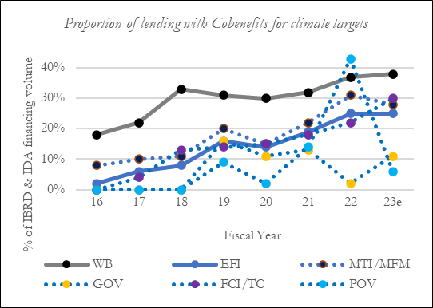
The reform helps refocus EFI Climate Cobenefits and ASAs on more impactful and macro-aligned prior actions. Since FY16, EFI has raised Climate Cobenefits from 8% to a 25% forecast this year. Last year, the EFI VP committed towards MDs to progressively raise EFI’s share to 40%. Even if this target was achieved, the global share of official climate finance supporting policy reforms would stay below 10%. Going further bears risks. It is essential not just to push more green content into DPFs, but also to improve the fit of climate content with traditional macro and financial stability goals. EFI needs to avoid additional climate content of DPFs pushing out core macro-financial content. Such trade-offs are also unnecessary: there are reforms that can make major contributions to both climate and macroeconomic objectives (see annex). But as of today, EFI economists and clients typically lack knowledge and incentives for implementing such reforms. To achieve their Cobenefits targets, Country Economists instead often “borrow” sectoral reforms from other VPUs. Many of these prior actions are not well aligned with macro strategies and typically do not deliver major climate progress either. The 128+ ongoing EFI climate ASAs seek to build knowledge for doing better. But country teams and ASAs would benefit from a clear identification of the core policy reforms they should aim for. Tracking the number of transformational climate-macro reforms would be more meaningful than Cobenefits tracking – helping to orient EFI country teams. And pinning down the core reforms would help align ASAs with core operation needs.
The reform ties into a broader strategy proposition. To get far in integrating climate with macro-financial objectives, three steps are needed. The first step is to create capacity on climate change that is tailored to EFI clients. When clients then signal their wish to go forward, the second step is supporting them with country studies that provide the integration of climate content with macro-financial objectives by including climate in core diagnostics rather than stand-alone studies. The third step is using these studies to strengthen DPFs with integrated climate-macro reforms, and reward such DPFs with top-up climate finance. Steps 1 and 2 are supported by EFI’s CSF program; the proposal here realizes step 3. Together, large synergies apply.
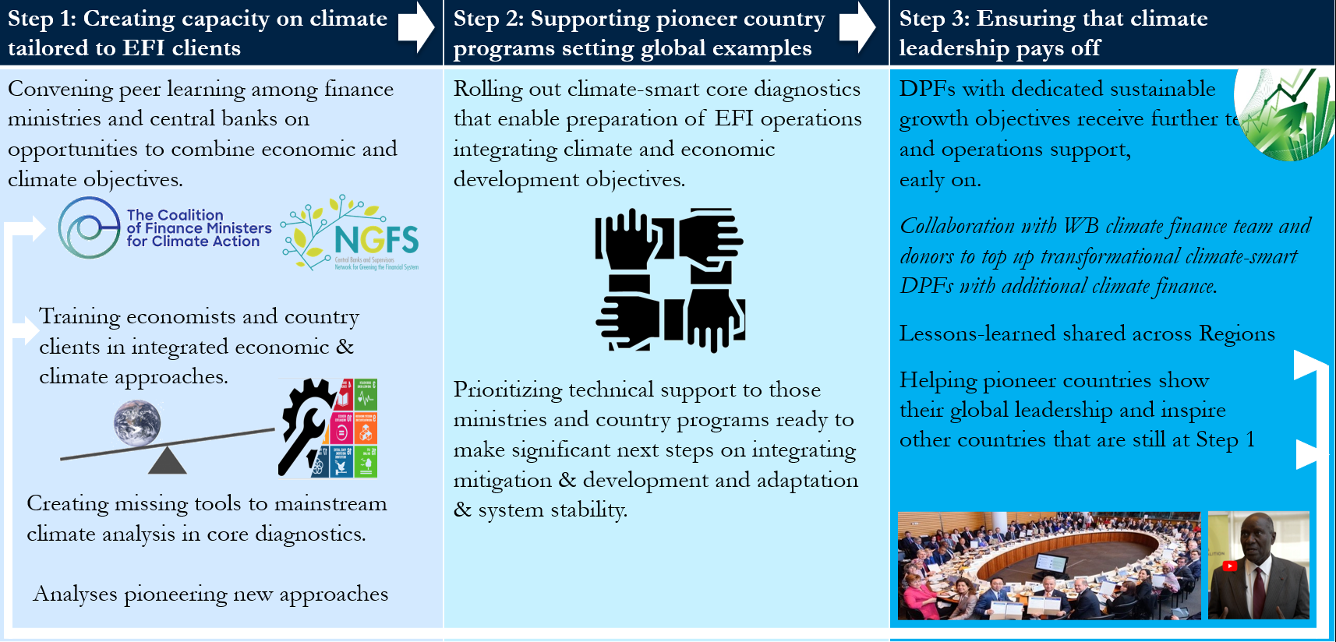

Draft List of Transformational Climate Policy Reforms Backed-up by EFI GP Programs

Selectivity Criteria
Setting out a list of policy reform archetypes justifying top-up climate finance requires clear selection criteria. One candidate criterion is the extent to which a policy reform generates spill-over benefits to other countries. That criterion, however, has the downside of requiring teams to show how other countries benefit, whereas climate action in developing countries should continue to focus on aligning climate action with domestic goals. It is laudable when a country undertakes climate action yielding global benefits, but to sustain climate action in the long run, as well as to align with core EFI objectives, reforms must be designed for domestic economic benefits. Here we therefore propose selecting policy reforms based on another criterion: the extent to which a reform generates transformational change.
We define transformational change in accordance with the WBG Guiding Framework on Climate Finance. A reform is transformational if it significantly reduces the barriers to implementation faced by future climate-related programs or projects. In other words, the reform generates increasing returns to scale by reducing future costs. It not only delivers climate benefits today, but also makes it easier to implement future programs or projects that will reduce emissions or boost resilience.
Mitigation-related reforms are transformational when, once implemented, barriers to implementation have been reduced for subsequent mitigation projects, thereby also reducing future needs for concessional climate finance support. This is generally the case if the program fixes market failures (e.g., removes disincentives created by distortive tax systems that promote fossil fuels), builds institutional capacity (e.g., creates a functioning regulator for energy markets), or generates innovative spillovers (e.g., demonstrates the viability of a sustainability-linked financial instrument in a country). Ideally, reforms help reach a “tipping point” beyond which future mitigation projects will not require concessional climate finance (i.e., when a low-carbon option becomes least-cost and can attract commercial finance).
Resilience-related reforms are transformational if they (A) improve the system-level stability of an economy against “cascading climate damages” and “compound damages” of climate shocks (economy-wide climate impacts), or (B) make it significantly easier and cheaper to adapt to climate change and reduce future climate and disaster risks (sectoral physical impacts), and thereby reduce future needs for concessional climate finance. Criterion (A) is satisfied when a reform improves the system resilience of an economy to recover from large shocks without hysteresis effects (e.g., improves debt sustainability, financial stability, insurance, countercyclical fiscal policy and generally the creation of fiscal buffers, and social security). The transformational potential of the reform can be evaluated, ex ante, through system-level stress tests for large shocks, identifying whether they have persistent detrimental effect for long-term socio-economic development. Criterion (B) is satisfied when a reform fixes market failures (e.g., removes property tax incentives to build housing in flood plains), builds institutional capacity (e.g., creates a risk-informed land-use plan or improves building regulations), or generates innovative spillovers (e.g., develops a hazard map that can be used for all future investments). The transformational potential of the reform can be evaluated, ex ante, based on its impacts on barriers to implementation that future programs or projects will face (e.g., the effects on future prices of a key technology, or on implementation capacity in a country).
A further criterion for the transformative impact of both mitigation and adaptation reforms is whether the reform type is politically sustainable in a developing-country context. For EFI operations in developing countries, economic development is the core priority. It is not realistic for poor countries to sustain climate policy reform types that slow domestic economic development. Therefore, a transformative climate policy reform must combine good climate and development outcomes.
The below list is a tentative draft. Going forward, two refinements are recommended. Firstly, EFI may wish to start with a narrowed-down version of the below list that focuses on those reform archetypes for which policy impacts can already be quantified. EFI could first leave out reforms for which such quantification methodologies do not yet exist while expediting efforts to create these. Over time, the archetypes of policy reforms that are eligible for top-up climate finance could then be expanded, while starting from a subset for which the transformational impact is already best-established and for which consultations with clients and donors should hence be easier. Secondly, the list can be further refined through additional consultations across GPs.

Fiscal Policy

Carbon Pricing
Carbon pricing has transformative impact by incorporating climate constraints into profit maximization. This policy comes in the form of “direct” and “indirect” carbon pricing. Direct carbon pricing includes (1) carbon taxes and (2) emissions trading systems and (3) tradeable performance standards. These instruments price goods in proportion of carbon content and have an explicit climate purpose. Indirect carbon pricing covers fiscal instruments that raise the price of carbon-intensive goods without proportionality and often targeting other main purposes. These policies include (1) raising taxes or lowering subsidies on fuels or other carbon-intensive commodities (including deforestation-related agricultural and mining commodities), (2) emissions feebates, (3) removing fuel price ceiling rules, and (4) removing restrictions to electricity cost passthrough including framework regulations on associated Power Purchase Agreements. There is evidence that direct carbon pricing can have greater impact on emissions than indirect carbon pricing, but that indirect carbon pricing is more widespread in developing countries, can be more easily sustained by established administrative systems, yield lower risks for revenue management, and often yield larger reform sizes. Therefore, this list considers both reform types as potentially transformative. The World Bank would be a potent partner for this reform archetype because it has impact assessments available for all client countries. Therefore, carbon pricing is proposed as a key reform archetype to be included in list of DPF prior actions qualifying for top-up climate finance. Given the wide set of these policy instruments, the proposed list could include a quantitative criterion specifying that eligible reforms need to yield a threshold increase in overall, economy-wide carbon pricing. The required methodology is ready.

Fiscal Technology Policies
Fiscal policies beyond carbon pricing are generally necessary, especially in developing countries. The turnover rate of emissions-intensive durable assets is often low, and durables often continue to be used even when they pose high operations cost. Such situations create poverty traps and lock in emissions. For example, citizens can keep using a gas-guzzling car even when fuel prices are high because they are credit-constrained in upgrading to more fuel-efficient vintages. Likewise, energy-inefficient machinery can be used long past its economic lifetime. Therefore, it can be transformational for governments to reform taxes, subsidies and tariffs on durables that have large emissions impact over their lifetime. This reform archetype includes scaling taxes on durables according to emissions (e.g., taxing cars by CO₂/km, taxing properties by energy consumption) and fiscal incentives for green technologies (e.g., reduced import tariffs on solar panels), or Contracts for Difference (see below).

Ecological Fiscal Transfers
In many countries, climate policy targets are set at the national level, but their implementation depends on decisions by subnational governments. These often lack incentives, e.g., when subnational enforcement of a forest law reduces short-term local economic opportunities and associated subnational revenues. But there is a tested solution to these institutional problems. In many developing countries, subnational governments receive budgets from formula-based intergovernmental fiscal transfer systems. Central governments can incorporate environmental progress indicators into these formulae, so the size of budget transfers varies according to the subnational governments’ attainment of agreed environmental objectives. This can be a powerful and revenue-neutral incentive system. It works like the WBG’s own formula-based IBRD/IDA envelope system where country allocations vary depending on CPIA scores. There is evidence of transformative impact from these reforms, especially in addressing land-use emissions, and the WBG has the needed technical capacity to support such reforms.

Climate-Smart Fiscal Rules
Many debt-constrained countries need fiscal rules to rebuild strong public finances. In many cases these fiscal rules work by constraining public spending. If so, the design matters greatly for both fiscal and climate objectives. There is evidence that many governments react to expenditure constraints by cutting long-term public investments rather than short-term government consumption. But cutting public investments often causes a more persistent reduction in long-term output potential than cutting government consumption, thus compromising the long-term debt-to-GDP ratios which the fiscal rule seeks to improve. Such side effects of fiscal rules are also a problem for climate action because government expenditures on climate typically come in the form of long-term investments rather than government consumption. Therefore, both fiscal/growth and climate objectives can be supported by a more careful design of fiscal rules which differentiates by the type of government expenditure. Fiscal rules can be designed to put greater constraints on government consumption than on long-term public investments that prove a persistent contribution to economic growth. These fiscal rules are called “Golden Rules”. Climate-related investments can be included in a list of investments contributing to long-term growth as they raise the resilience of the country to climate shocks and the changing opportunities in a decarbonizing world economy. These “Green-Golden Rules” are transformative because they improve the foresight of fiscal policymaking, safeguard long-term sustainability objectives during times of short-term crisis, apply at a large scale, and improve the predictability of fiscal policy and its associated market signaling power. The WBG has the needed capacity for this policy reform archetype due to its long-standing experience with fiscal rules, and it has the endurance to accompany these changes over time because doing so aligns closely with needed reforms for addressing the current twin crises of rising public debt and decelerating long-term growth potentials.

Green Public Procurement
There is strong evidence of increasing returns to scale in both mitigation- and adaptation-related technologies. These increasing returns apply not just at a global scale, where developing countries are often insufficiently large to make a difference, but also on the local scale due to the existence of fixed costs to local adaptation of technologies and network externalities for users. This means that, also in developing countries, stimulating green growth requires technology adoption at a minimum efficient scale. That nonlinearity, in turn, is a key barrier to establishing new low-carbon climate-resilient markets. To overcome these barriers, the state can provide an initial push to green products and practices. This can be done by incorporating climate-related criteria into public procurement systems. The state’s purchasing power has a key potential for developing green technologies to the minimum efficient scale from which onward unit costs are sufficiently low for free market penetration. Additionally, the signaling power from the government’s commitment to these procurement practices helps coordinate market expectations for the breakthrough of these technologies, leveraging further private investments. There is ample evidence and best-practice examples for green procurement, indicating low administrative barriers for transformative impact. Also, in many value chains and developing countries, there are existing private-sector sustainability certification systems. The public sector can reuse those systems, lowering administration costs, and creating transformative incentive effects for the market penetration of these certification systems. The World Bank has the needed capacity for this policy reform archetype from its experience in reforming public procurement systems, as well as a program on private-sector business environments that would enable linking these procurement practices with private-sector sustainability certification systems.

Climate Budgeting and associated Climate-Smart Public Financial Management
Notwithstanding the arguments made above on possibilities to reduce climate-related expenditure needs, climate action is widely seen to require large public investments. Given the scarcity of public funds, these investments must become much more transformational. But many Finance Ministries lack even basic systems for tracking, planning and surveilling climate-related public expenditures, which are often scattered across line ministries. The World Bank, UNDP, OECD and others have long assisted Finance Ministries in establishing such systems. These reforms would continue to be supported through this program. However, to be eligible for top-up funding, reforms would need to satisfy a set of minimum quality standards. (1) Many existing programs of Climate Budgeting in developing countries count only climate-positive expenditures, when low-carbon structural change is instead determined by relative public expenditures for climate-positive and climate-negative outcomes. For example, many Climate Budgeting programs would only count a subsidy for renewables but not one for coal, when the two may cancel out each other. To classify as a transformational reform, Climate Budgeting reforms supported through this program would track the relative spending towards climate-positive versus climate-negative structural change. (2) Many existing Climate Budgeting programs do not account for tax expenditures. Yet, the majority of climate-negative public expenditures in most countries is undertaken through tax expenditures rather than direct expenditures. Without incorporating tax expenditures, it is not possible to verify how overall fiscal incentives change. Therefore, only Climate Budgeting systems that incorporate tax expenditures would be considered as transformational policies eligible for top-up. With these changes, the World Bank would have significant experience and capacity to support another key reform archetype across countries.

Public Investment Management with Long-Term Strategies
To reach climate targets, Finance Ministries seek the least-cost climate investments. Unfortunately, identifying those least-cost options has proven hard. The determination of least-cost option critically depends on the time horizon considered for the amortization of investments. Traditionally, policymakers have chosen least-cost investments by calculating Marginal Abatement Cost Curves – the so-called “McKinsey approach”. But a key finding from the climate economics literature of the last 30 years and the CCDRs is that minimizing the total cost of climate transitions requires going beyond marginal cost calculations and costing technology pathways over a longer time horizon. For example, the US Inflation Reduction Act or the German renewable energies laws specifically targeted technologies that have high unit costs to bring those costs down with cumulative scale. The World Bank is providing countries with support to operationalize this approach by designing Long-Term Strategies (LTS). The next step is then to use these LTS for reforming public investment management. The latter is a policy reform that can be financed. To be impactful, what is important here is not the LTS itself (which is just a document) but its operationalization. To be counted as transformational and eligible for top-up climate finance, such DPF prior actions would therefore not focus on the development of an LTS itself but the operationalization of LTS in public investment management.

Management of Climate-Related Fiscal Risks and Climate-Impacts for Debt Sustainability
Climate change, domestic climate policy and global decarbonization are increasingly causing fiscal risks. Yet, few client countries are considering these risks in their fiscal risk management strategies. Even in countries that are frequently hit by natural disasters, forward-looking management of associated fiscal risks is rare. There is a discrepancy here between national central banks and finance ministries: 125 central banks and national financial supervisory authorities are already warning of climate impacts on financial stability (NGFS) with the Bank of International Settlements warning of an unprecedented and potentially near-term financial crisis caused by climate transitions. It is well known that financial crises tend to yield large fiscal risks. Yet, finance ministries in the same countries of those concerned central banks do not consider these risks in their fiscal risk management systems. Meanwhile, Fitch, Moody’s and S&P all warn that climate vulnerability is affecting sovereign risk ratings, which can already be seen in debt financing costs. It is therefore essential to support countries in reforming fiscal risk management and debt management to account for climate-related risks. The World Bank is currently developing this technical capacity and has existing global programs to leverage for supporting this reform archetype.

Trade Policy

Tariff Reform
In most countries, green technologies face higher tariff barriers than high-carbon goods. This amounts to more than USD 500bn per annum in price incentives against decarbonization. Furthermore, as carbon is concentrated in upstream stages of global value chains, this tariff structure increases the barriers for developing countries to diversify from basic resource extraction. This tariff structure is thus both a climate and a development problem. It should then be included in a list of transformational reforms. Given the large number of tariff rates that countries could change, determining whether a reform is transformational for climate action would require a quantitative threshold for impacts on economy-wide incentives.

Sustainability Certification
In most carbon-intensive Global Value Chains, major private-sector initiatives are underway to identify, standardize and certify available sustainable production methods. The WDR 2019 emphasizes the importance of further supporting these certification efforts, but also for complementing certification with public policy. There are a clear set of policy reforms that countries can undertake to unblock sustainability certification systems to integrate into green value chains.

Reforms adapting to Carbon Border Adjustment Mechanisms
The World Bank is increasingly advising client countries on impacts of Carbon Border Adjustment Mechanisms that are being introduced in large consumer markets (EU, UK, with others impending). These systems recognize policy reforms in developing countries, but raise multiple complexities. Client countries will need technical support in designing climate policy reforms that help them secure those more favorable trade terms.

Reforms adapting to Market Access Rules controlling “Imported Deforestation”
Many client countries are affected by new legislation in the EU, USA, UK and Australia constraining market access for commodity exports associated with deforestation. Client countries have multiple policy reform options to cut down on deforestation linked to their exports. Supporting countries with implementing such reforms can be transformational for combining climate mitigation with maintaining free trade. For example, Cote d’Ivoire and Ghana currently face potentially disastrous consequences of losing market access to the EU and USA due to deforestation and child labor problems in the cocoa value chain. The World Bank has the needed experience to support client countries with policy reforms reducing deforestation from export goods.

Financial Sector Policies

Greening National Development Finance Institutions
Institutional reforms to the world’s 450 national development finance institutions (NDFIs) can promote sustainability goals worldwide. Sustainability often requires long-term funding and stable market signaling, and NDFIs can offer stable, long-term funding in national currencies that reduces uncertainty, mitigates external vulnerabilities, and promotes diversification, innovation and crowding-in. In addition, NDFIs can insulate technology choices from lobbying pressures and develop the necessary technical capacity for establishing low-carbon markets. Moreover, NDFIs can sustain stable structural change along election cycles, which can be a greater challenge for Finance Ministries acting alone. There is an opportunity for DPF-supported institutional reforms to align existing NDFIs with national climate goals, refocusing operations and portfolios accordingly.

Climate Bad Banks
Global low-carbon structural change creates major spillover risks for stranded assets in developing countries. There is a broad consensus among central banks and financial supervisory authorities on the ability of national policy reforms to reduce exposure to these risks. One such strategy for reducing this risk exposure is the use of Bad Banks to cleanse the balance sheet of economic agents from elements endangering their financial viability. For example, in the 2007/2008 financial crisis, Bad Banks were established as purpose vehicle to offload toxic assets from subprime mortgages. While such policies incurred public costs, they are credited for having prevented an even worse financial crisis. Some countries have started applying this model to carbon-dependent assets at risk of the global transition. In Poland, for example, coal power stations are currently becoming stranded assets and are burdening the balance sheets of the power sector to move into renewable profit opportunities. The government therefore created a Bad Bank-type vehicle for offloading those stranding assets. More generally, Climate Bad Banks can house those assets exposed to transition risks. Once the assets are transferred, the Climate Bad Bank may have three different goals. It can seek to liquidate the assets as quickly as possible (by selling them outside the country to investors willing to bear that risk), carry out proper asset management to make non-performing assets eventually perform, or conduct an “extinctive management” of the assets, for the soft-landing of dying businesses. Such policies can help unstuck financial institutions to expand low-carbon investments, and reduce the aforementioned crisis exposure. Early policy action can avoid transition-exposed assets being transferred to less regulated and less solid financial agents. Their optimal design relies on three main - intertwined - challenges for such institutions: of economic efficiency, justice and governance. DPFs could help client countries in adopting best-practice designs.

Green Taxonomies and associated Implementing Regulations
Many developing countries use green bonds for mobilizing low-carbon investments from the private sector. However, the development of efficient and transparent green bond markets requires identifying what counts as green. This can be achieved through “green taxonomies” – which define criteria for evaluating sustainability impacts of financial assets. For a decade now, such taxonomies have been used by the private sector – now they are efforts to align with public policy. Finance ministries and central banks have now developed official taxonomies in several jurisdictions (e.g., China, Colombia, Malaysia). Such strengthened taxonomies can become key instruments to mobilize climate finance, including for green budgeting. But implementing such reforms requires careful policy design. It is especially hard to establish green taxonomies in “hard-to-abate” sectors where the low-carbon transition will take time such that activities today are still highly carbon-intensive, and where making the change requires especially large investments. In these sectors, it is essential for forward-looking firms to be able to signal to financial markets when they are gradually becoming sustainable. A strong green taxonomy recognizes the need to “transition away” from a legacy of unsustainable activities, and that this transition also requires massive investment. This is especially true in emerging economies, which are generally more carbon-intensive. The Sustainable Finance Disclosure Regulation provides a scalable template for improvements in the transparency of the market for sustainable investment products, to prevent greenwashing and to increase transparency around sustainability claims made by financial market participants. World Bank DPFs could help implement this regulation in developing countries, and thereby help client countries avoid being disconnected from growing green financial markets.

A key novelty in green finance is the emergence of Sustainability-Linked Bonds. Different from green bonds, SLBs are not restricted to specific projects or expenses – instead, their payout to bondholders depends on the agreed-upon performance indicators, which is an incentive instrument. This means that SLBs can be part of a broader shift from an overreliance on climate project finance to policy incentives. However, floating Sustainability-Linked Bonds requires the introduction of measurable Key Performance Indicators, and such KPIs must be designed in a robust manner and align with country contexts. An important precondition for robust KPIs is the development of proper data infrastructures and associated institutions. Sustainability-linked instruments can then offer financial rewards to borrowers based on their success in achieving predetermined sustainability objectives. These various steps can be supported through the World Bank. For instance, Uruguay recently implemented such policy and institutional reforms which then helped successfully issue its first sustainability-linked bond. This is therefore another potential transformational policy reform archetype for top-up climate finance.

Development of Climate-Related Financial Metrics, Certification Labels, and Disclosure Standards
Public authorities can play a crucial role in defining disclosure and reporting standards in nascent green financial markets. Such reforms can improve transparency, increase awareness of climate-related risks and investment opportunities, facilitate communication with stakeholders, and ultimately enable the efficient allocation of capital towards a low-carbon and climate-resilient economy. Financial regulators, for instance, can set specific disclosure requirements for financial institutions, while conduct or capital markets regulators can support and enforce sustainability reporting and labeling practices for listed companies. Several international initiatives are underway to establish such regimes and WBG DPFs can help client countries with national implementation. DPF reforms can also help connect client countries with emerging international practices in risk rating, external review and verification of climate-sensitive assets.

Green Asset Purchase Programs
Asset purchase programs like Quantitative Easing are only used in some developing countries, but where they are used, a key reform can be to incorporate criteria for climate-related asset risks. Green asset purchase programs, or Green Quantitative Easing, incorporate preferential targeting of low-carbon assets. The reforms have three direct impacts. First, they contribute to expanding the central bank’s balance sheet by creating new bank reserves in exchange for the assets purchased by the central bank. Second, they contribute to changing the eligibility criteria of banks’ assets that can be purchased by the central banks. Third, they lead to an increase in banks’ liquidity, thus increasing the amount of money in the economy. These impacts give rise to new transmission channels which can address risks that climate change and climate transitions poses to monetary policy.

Regulatory Frameworks for Trading in Climate-Impacted Commodities Markets
Climate change is expected to exacerbate fluctuation in commodity markets, which can have profound economic and poverty implications. Countries are therefore interested in reforms to mediate such fluctuations, including fluctuations for non-climate reasons which compound the climate-related fluctuations. One aspect here is the increased financialization of global commodity futures markets, as commodities are becoming an asset class for speculative purposes. Financialized commodity markets can improve market liquidity and price discovery and allow financial market participants to hedge their investments. Yet, regulation and supervision of commodity derivatives markets, notably to strengthen transparency and address market abuse, is important to avoid price volatility and misuse. This includes improving transparency of information about commodities (spare capacity, stock holdings, short-term demand forecast), information on commodity derivatives markets with respect to position-taking by different market participants, setting position limits, and strengthening market surveillance authorities to avert price collapses and bubbles.

Climate-Resilient Debt Instruments
Many climate-vulnerable countries also face high debt levels, which raises concerns of climate shocks unleashing cascading damages for financial stability. One reform type for mediating these problems is Climate-Related Debt Clauses (CRDCs). This refers to the forward-looking incorporation of contingency clauses in debt instruments which allow the deferral of a country’s debt repayments in the event of a pre-defined, severe climate shock. As such clauses are priced into debt instruments, they create a form of disaster risk insurance. CRDCs suspend debt service repayments for a pre-agreed period when a pre-defined climate shock hits to free up cash-flow that could be better used to support disaster relief.

Climate-Financial Risk Assessments
Most policy and institutional action on climate change by central banks and financial regulators will require initial climate risk analyses. Helping clients get started with such analyses can therefore be transformational. To conduct climate financial risk assessments, countries need a framework for forward-looking physical and transition risk scenarios, as well as mapping country-specific transmission channels. The results of these analyses are then published and communicated to stakeholders to facilitate market adjustment such as divestment from carbon-dependent assets. Understanding risk channels and vulnerabilities is essential in informing supervisory priorities and enabling a risk-based supervisory approach. Quantitative assessments are significant in informing supervisory action to provide detailed guidelines for the banking sector on risk management, governance, stress-testing, and reporting. Identifying data gaps is also important in developing a strategy to bridge those gaps, including through guidance on disclosure and regulatory reporting.

Innovation Policies and Macrostructural Reform

Institutional Reforms for Creating Markets
Many markets for low-carbon technologies do not yet exist. Often, the rules are not set for low-carbon investment. For example, in many countries, rules for feeding renewable electricity into otherwise coal or gas-dominated grids have not been set, which means that renewables operators have no mechanism to sell electricity to consumers. Furthermore, in many countries, mechanisms for trading low-carbon commodities such as green hydrogen do not exist. A market-creation policy reform can involve developing market trading rules (e.g., auction rules in power markets), creating a market regulator, creating institutions that aggregate demand across users to ensure predictable demand for suppliers to reduce investment risk, and ensuring availability of supply for users by coordinating investment in supply capacity. An example of this is the creation of a facility that clears demand and supply for future contracts of green products to enable the private sector to invest in production and use capital without excessive risk.

Market Liberalization
Even where low-carbon technologies are least-cost, they can be foreclosed through market access barriers. For example, in many developing countries, electricity markets are operated by state-owned monopolists and do not allow independent producers to feed electricity into the public grid. These market barriers can be motivated by Political Economy: renewable energies can often operate at a smaller scale without traditional SOE structures, so allowing cheap, low-carbon and decentralized energy can upset political power structures. SOEs can prefer to instead stem the low-carbon transitions without new private actors, but then lack the investment capacity to do so, instead perpetuating the status quo. Liberalizing such markets enables other investors, bringing external resources, to participate in decarbonization, and unleash the efficiency of the private market. Reforms then involve abolishing legal barriers to market access, reforming SOEs and regulators.
Market instruments, such as carbon pricing, are typically best combined with reforms of markets to be more market-oriented. In many client countries, there are pre-existing fuel purchase agreements. Power purchase agreement reform can, for example, replace existing contracts with a contract of higher value that avoids obligations of physical delivery or where that delivery can be satisfied from other power sources, such as renewables. It also important that markets are contestable - for example a power market should be accessible to new renewable energy sources, which can often require reforming SOEs and market regulators.

Public-Private Partnerships for Nascent Technologies
The costs for many low-carbon technologies accrue upfront. It is sometimes clear that green technologies have the potential to become competitive if deployed at scale, but despite that, the necessary investments may be excessively risky for the private sector to the extent that they deter participation. The public sector can partner with key private sector participants to develop demonstration projects by co-owning innovation risk. This allows to experiment with, demonstrate and expand production scale for green technologies in early stages of development, which brings down costs and risks in such a way that eventually makes them manageable by the private sector alone.

Contracts for Difference
In many situations of early-stage technology development where technologies are near-competitive, market risk mitigation can be more important to private-sector investors than relative cost minimization. Since low-carbon investments often have a long lifetime, ensuring a stable price over an investment project’s lifetime can be more important than deterring the competition. Excessive uncertainty over the profitability of marginally competitive low-carbon projects generally deters investment. One mechanism that has been successful in crowding-in low-carbon private investment is the contract-for-difference (CFD). In such a contract, a strike price is agreed between an investor and the government through a reverse auction. The contract stipulates that any difference between the future sale price and the strike price must be paid off to the counterpart, depending on whether it is positive (a windfall profit for the private operator is paid back to the government) or negative (the government subsidizes the operator if the sale price declines below the agreed price). The CFD mechanism has driven success in many renewable electricity deployment activities worldwide, and the evidence suggests that it generally works more effectively in scaling up new risky technology than carbon taxes/markets, the latter which can make renewables projects competitive but do not reduce uncertainty. Such contracts provide long-term price certainty, and therefore revenue certainty, which reduces financing costs. These contracts are especially important in high-risk environments, such as developing countries.

Harmonizing Regulatory Standards
For many green technologies, global initiatives are underway to harmonize regulatory standards and thereby expand market volumes. For developing countries, it is important to sustain and improve access to the Greentech markets of the future by aligning with these regulatory standards. The World Bank can support such reforms. Harmonizing regulatory standards internationally and aligning investment strategies in new technology can help expand potential market volumes for green technologies and products, attract more domestic and foreign investment and reduce costs. This includes trade rules and makes a fundamental component of, for example, Climate Clubs. Partnering on innovation can also involve cross-border knowledge sharing, joint projects and joint infrastructure, which reduce deployment costs.

Annex: Typology of Climate Risks for Identifying Transformative Adaptation Policies in EFI DPFs
A much wider set of EFI DPFs can make transformational contributions to climate resilience than is often believed. To understand why, it is imperative to have a typology of climate-related risks and associated resilience measures. We can broadly distinguish five types of these risks.

Physical Risks
Physical risks refer to impacts on the economy that arise directly because of an extreme-weather event, such as destruction of physical assets like roads or production facilities. Adapting to these risks includes hardening infrastructure, etc., which are reforms outside the scope of normal EFI DPFs, but can relate to EFI through risk financing and risk regulation, including in conjunction with operations of EFI’s Global Shield Against Climate Risks.

Domestic Transition Risks
These are impacts on the economy arising from a country’s own climate transition, such as a country’s own shift away from coal inducing bankruptcies of coal companies. Adapting to these risks includes avoiding abrupt policy changes, allowing the transition towards a country’s climate targets to occur gradually, with steady and early policy signals rather than delaying action first and undertaking drastic clean-up later. This relates to fiscal and financial policy DPFs that advance earlier policy reforms, which can then be more gradual, to divest from asset types at risk of stranding, as well as equity-oriented policy reforms like safety nets for workers, firms and regions that are harmed by the structural change.

Global Transition Spillover Risks
These are impacts on the economy arising from other countries’ climate transitions. As a share of the world economy decarbonizes, it induces changes in the external demand for commodities (e.g., raw materials) and carbon-dependent assets (e.g., refineries) felt in third countries. There are also spillover effects stemming from the fact that most global R&D centers are now in countries with long-term net-zero emissions targets, thus impacting development strategies reliant on imported innovation. There is evidence of increasing returns to scale in a host of high- and low-carbon industries, which implies spillover effects to unit costs of production, including risks of stranded assets. Another global spillover risk for developing countries comes from abrupt shifts in global financial market valuations of carbon-dependent assets (e.g., for refineries) as other countries decarbonize or implement regulations on their global investors. These risks have been small historically but there is a consensus among central banks that these risks may abruptly become large. Adapting to these risks includes reducing the share of a country’s wealth held in asset classes that vulnerable to spillover risks (e.g., carbon-dependent assets) and strengthening the more climate-resilient types of national wealth (e.g., human capital, or asset types which will benefit from the future net-zero economy).

Cascading Risks

These are knock-on effects caused by any of the former three risk types. For example, when a drought causes migration causing conflict. Or when the bankruptcy of coal companies causes financial risks to banks who lent to the coal sector, causing financial crises, requiring government bail-outs, causing debt. These are chains of damages where a first shock is sufficiently large to cause another shock (domino effect), or where recovering form one shock is made harder due to the occurrence of another shock. The macroeconomic reader will know such cascade risks from the literature on depression economics. Poverty specialists know such cascade risks from the poverty trap literature. Financial specialists
To illustrate, we can consider the example of a flood (initial shock), which may cause cascading impacts (“domino effects”) as the flooded areas experience migration, firm bankruptcies, diseases… Resilience can mean stopping the initial shock (pictured here) or stopping transmission channels when the initial risk unfolds – which is more realistic the larger initial shocks become (as climate shocks either intensify or increase in frequency and compound with other shocks) and the greater pre-existing vulnerabilities are.

know such cascade risks from macroprudential policy.

Compound risks
Each of the above categories of climate risk can combine with general macroeconomic shocks, with an amplified compound impact. For example, the risk of a hurricane (physical risk) causing a debt crisis (cascading risk) is amplified if other recent non-climate shocks already eroded fiscal space.
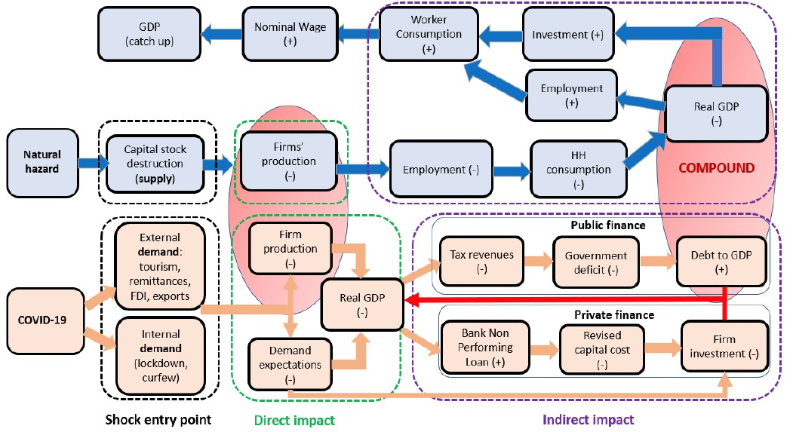

Climate-related risks often compounded by non-climate risks to cause disproportionate harm, e.g., in this example of impacts from the COVID shock exacerbating the effects of a natural hazard (FCI 2021).

From an EFI perspective, these interaction effects between types of climate risk and general macro/financial risks are at the core of the VPU’s role in building climate resilience. DPF prior actions that strengthen debt sustainability, financial stability, insurance, countercyclical fiscal policy and generally the creation of fiscal buffers, social security (…) enhance the resilience of economies to macroeconomic shocks in general. And because the climate risks are often compounded by other shocks, such prior actions reduce the risk of physical risks causing cascading damages. When this system-level resilience is achieved, the economic impacts of physical climate damages can be much reduced – the physical damage can still cause significant short-term suffering, but the risk of long-term damages to economic development is reduced.
For most EFI DPFs, these cascading risk and compound risk considerations are at the most relevant for climate adaptation. Most EFI prior actions do not directly affect physical risk. But there are many prior actions which reduce risk factors that compound with physical risk, or that mitigate potential cascading damages which could be unleashed by physical risks. These risk types should hence lie at the core of an EFI product for transformational climate action. This, in turn, means that EFI could relatively easily identify transformational policy reforms on adaptation, that the VPU has key role in building resilience, and that such efforts can align well with broader macro-financial objectives.

BIS 2020. Summarized here.
Sources by quadrant: CPI 2022; OWID; CPAT; GEP; CPI 2022; Bloomberg NEF; IEA 2022; Shapiro 2021; MTI, DEC, & CCG 2023.
AfDB, ADB, AIIB, CEB, EBRD, EIB, IDBG, IsDB, NDB and WBG 2022
Yellen et al 2019
Coalition of Finance Ministers for Climate Action
For example: a carbon tax (or a reduction in fuel subsidies) improves public finances in five ways. (1) It raises revenue. (2) It reduces the marginal cost of public funds. (3) It reduces overall investment needs for climate mitigation by reducing demand for high-carbon products (including through the rebound effect of project finance). (4) It increases the share of investment needs which can be shifted to the private sector. (5) And it increases the fiscal multiplier of remaining green public investments.
1bn USD in 2022, compared to 1tn and 6tn in direct and indirect fuel subsidies. Markets peaked in 2012 over wide-spread fraud and ineffectiveness but have recently rebounded (with similar problems).
Most economists agree that the most efficient climate policy is upstream carbon pricing – a policy design that efficiently reduces carbon while making tax systems more robust to informality, evasion and easing tax administrations. Carbon markets have been promoted in ways that encouraged developing countries to instead opt for downstream, project-level systems forgoing these macroeconomic benefits, exacerbating trade-offs between mitigation and development. This advocacy has become a key barrier to EFI efforts for aligning climate action with conventional tax policy.
This incentive problem can be fixed. In the Paris Agreement, countries have universally committed to net neutrality of emissions by mid-century. From the CCDRs and IPCC, there is also good information of needed near-term changes to achieve this net neutrality. It is therefore possible to test for the alignment of an operations with net neutrality instead of with the NDC. This way, perverse incentives to reduce the stringency of NDCs is avoided. This is also legally safer for the WBG because (1) the commitment to net neutrality is part of the Paris Agreement, NDCs are not (just the existence of NDCs is subject to the PA, not their content) so the current interpretation of the WBG methodology testing compliance with the Paris Agreement through compliance with the NDC is legally questionable. (2) The Paris Agreement calls for a “ratcheting-up” of NDCs towards mid-century net neutrality, so implementing a WBG Paris Alignment methodology that creates incentives against this ratcheting-up mechanism is appears inconsistent with the treaty. There are thus economic incentive reasons and legal reasons to reconsider the current methodology. Lastly, making the suggested change would also make WBG operations easier because it replaces a complex country-by-country variation in the definition of Paris Alignment with a uniform global standard – easing work for country teams.
Policy financing is needed at the time of the reform to pay for buffering transitory losses of politically influential or vulnerable groups. Consider a fuel subsidy reform: Over time, it more than pays for itself, meaning the country will not generally need continued concessional financing for that same reform. These long-term net opportunities hold in general for EFI-type climate policy reforms: they create long-term economic gains. The challenge for implementing such reforms is therefore short-term cost, not long-term cost. And hence the policy financing is also needed at the time of reform, as in a DPF, rather than years after the reform, as in result-based climate finance.
In Brazil, results-based climate finance was provided to the Bolsonaro government (which rose to power in opposition of forest protection policies) for reductions in deforestation achieved by the predecessor government.
CSF Whole-of-Economy Climate Action Program
In the case of using SCALE, that facility should be broadened from its current focus on paying results-based climate finance four years after a reform to equally accommodating policy financing paid at the time of the reform.
WBG (2018). “Strategic Use of Climate Finance to Maximize Climate Action – a Guiding Framework”
See Annex on types of climate risks for identifying focus areas for EFI DPFs.
MTI, DEC, CCG & EEX (2023) “Total Carbon Pricing”
While credit ratings for corporate bonds and external reviews are widely used in advanced countries, they are missing in many low-income countries. However, as countries promote green finance, external reviewers are needed for ensuring the legitimacy of green bonds. Third-party verification is often used before and after issuing green and thematic bonds to ensure that bond proceeds are managed appropriately, according to the issuer's framework. For asset managers and owners, external verification provides an additional layer of due diligence to ensure that private capital is flowing as intended.

